

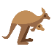



**Create your own wild animal!**

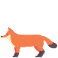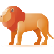

Name: __________________________

Habitat: ________________________________________________________

Diet: ___________________________________________________________

Weight: ____________________ Height: ____________________

Picture

How is your animal adapted to its habitat?