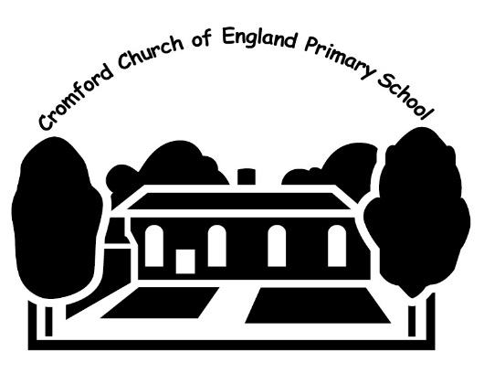 | Cromford C of E Primary School  North Street  Cromford  Derbyshire.  DE4 3RG  Telephone: 01629 822248  Fax: 01629 823737  E mail: info@cromford.derbyshire.sch.uk  Website: www.cromfordcofeschool.com  Headteacher: Mrs Elizabeth Foster, BA (Hons) QTS, NPQH
June 2020
Dear Parent/Carer
Our school milk scheme
Our school provides a milk scheme that is available to all of our pupils and we would like to invite you to register your child. School milk is free for under-5s, and for over-5s it is available at a subsidised* price of £0.89 per day.
Each child that registers with Cool Milk will receive a 189ml portion of semi-skimmed milk every day, delivered fresh and chilled to the classroom. Their school milk will not only provide them with essential nutrients, but as it is rehydrating and energy boosting it also bridges the gap between breakfast and lunch to help children stay focused. For more information on how milk can benefit children visit www.coolmilk.com/why-milk-is-great.
How to register
If your child is under five:
- Register online at www.coolmilk.com or complete a registration form available from the school office
- Register by a Tuesday at 5pm for your child’s free milk to start the following week
- Free milk will continue until the Friday before your child’s fifth birthday. You will receive a payment request four weeks before their birthday - if you wish your child to continue to receive school milk, simply make a payment

If your child is five or older:
- Register and pay online at www.coolmilk.com
- Alternatively, fill in a registration form available from the school office – once Cool Milk has processed your form, you will receive a payment request
- You can pay Cool Milk either online, over the phone or at a local PayPoint in half-termly, termly or annual instalments.
- Please pay by a Tuesday at 5pm for your child’s milk to start the following week

If you have any questions regarding school milk please visit www.coolmilk.com or contact Cool Milk directly on 0844 854 2913. More information on milk is also available from the school.
Yours sincerely

Mrs L Foster
Headteacher
* Milk for under-5s is provided free of charge, fully funded by the Department of Health. Milk for over-5s is subsidised by the Rural Payments Agency and the E.U.

